**Social Media Posting Image #1:**

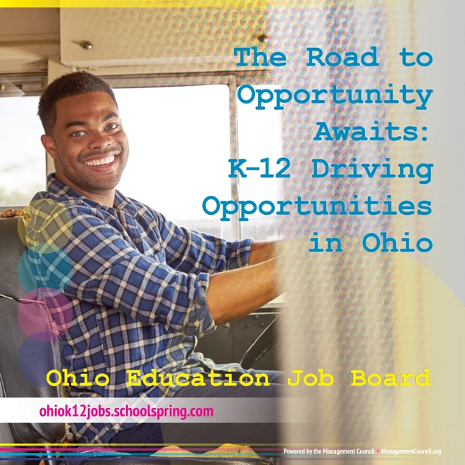

Social Media Posting Copy:

Drive your career forward with the best opportunities in K-12 education. Search the Ohio Education Job Board for your next job. Start applying today and connect with top school districts looking for dedicated drivers like you.

* Discover openings across Ohio
* Connect with school districts seeking reliable, qualified bus drivers
* Utilize the platform built specifically for education professionals

[https://ohiok12jobs.schoolspring.com](https://ohiok12jobs.schoolspring.com/)

**Social Media Posting Image #2:**

Social Media Posting Copy:

Looking for your next rewarding K-12 driving job? The Ohio Education Job Board is your destination! Create your candidate profile today and connect with schools in need of your expertise.

* Reach school districts across Ohio
* Find opportunities tailored for qualified bus drivers
* Explore the job board designed specifically for education professionals

[https://ohiok12jobs.schoolspring.com](https://ohiok12jobs.schoolspring.com/)